**实验2 课前练习**

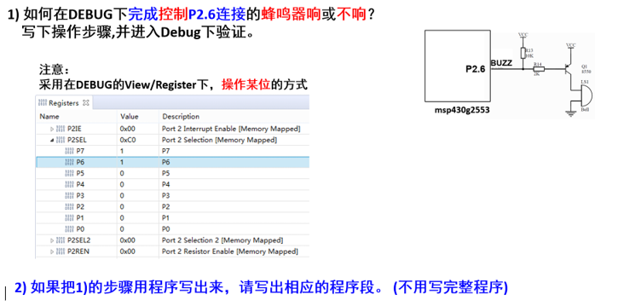

P2SEL &=~BIT6;

P2SEL2 &=~BIT6;

P2DIR |=BIT6;

P2OUT &=~BIT6;